**Running with Screwdrivers**

**Adventure Game Storyboard**

By Josiah Smythe



* This game is all about **Gathering Screwdrivers** that are scattered through rooms. To win the player must gather at least three screwdrivers from the different rooms. If three are acquired, the game will end, and you will be declared the “Winner!”
* When the game begins you will be prompted to begin from a saved game or to begin a new adventure. Then you will be prompted to explore your current room or move to a new one.
* There are four rooms and they are as displayed one the Game Map picture along with their names and relationships to one another. Note the compass in the top left-hand corner, it will be critical in moving your character to different rooms.
* Each room contains at least one object of the ScrewDriver type, and the description of each room and any Items therein will be displayed when you move into it. The items will be displayed in the form of, Name, Type, Description, Value, Purpose, isDangerous, percent dangerous, length. Example below.

[ScrewDriver, Phillips, Good for tightening screws, 175, Woodworking, false, 0, 6]

**\*\*\* Game Map \*\*\***

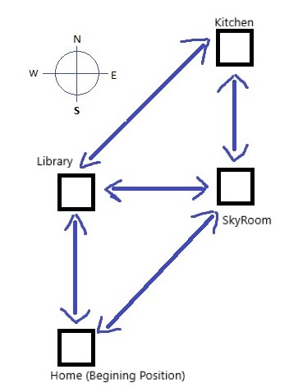

**[ *** Game Vocabulary *** ]**

[Move] To select what direction to move

[Explore] To look at items, pick them up, drop them, save the game, end the game, see the items in the room, look at your hand, and to look at the map, and look at the Vocabulary.

[Done] to stop moving or exploring.

[Quit] to exit the whole game.

[Look] to look at items at your current room.

[Hand] for hand to view your hand.

[PickUp] pickup the item in the current room.

[SaveGame] to save the state of the game to a file.

[Commands] To see game Vocabulary.

[Map] To see current room and movible directions.

[N, NE, NW, S, SE, SW, E, W] to move that direction.